WI TT1 syllabus

Module 1, 2, 3

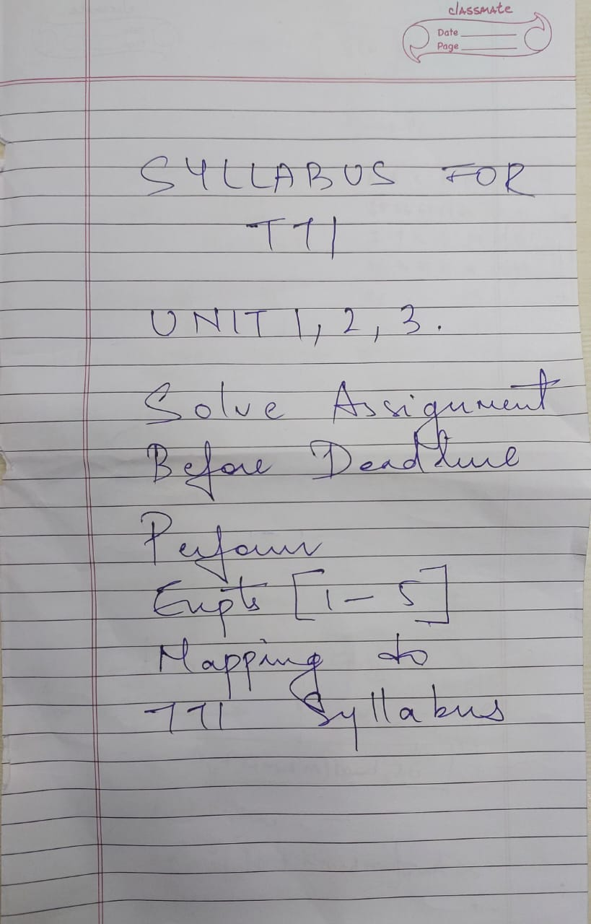

NOTE : Other questions maybe asked

Imp Qs –

Wi

Dom applications

XML tree as well

Use cases

Wi

Relevance feedback

Ir architecture

rochio okapi sum

Pm 25

Tried sum

Web mining vs data mining

Landmark wildcards imp

Types data rich pages

Page rank centrality prestige

Dom trees

All differences from assignments

Assignment qs